FOR IMMEDIATE RELEASE |  |  | CONTACT: Lawrence Gooley  E-mail: info@bloatedtoe.com
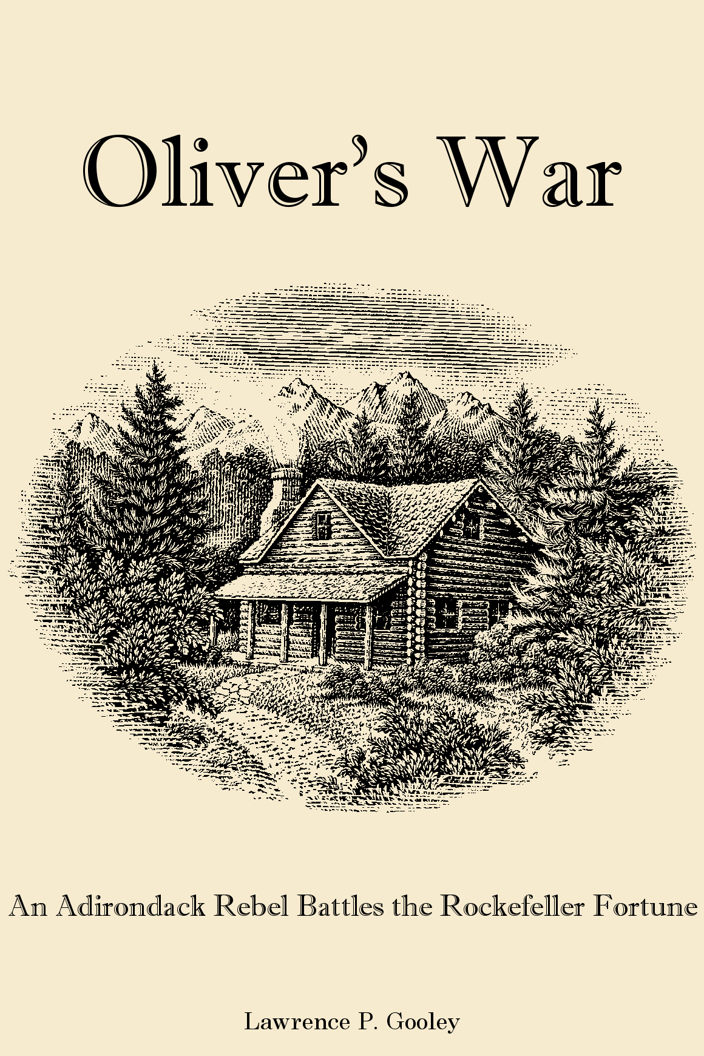 | Oliver’s War  An Adirondack Rebel Battles the Rockefeller Fortune  by Lawrence P. Gooley  Author is available for interviews
“This case is unquestionably the greatest case involving game preserves ever tried in America, and on its final result hangs the fate of the efforts to establish ‘parks’ in the Adirondack wild land …”

Forest and Stream Magazine, 1905
“Soon after my son’s murder, a newspaper clipping was sent to me, on the margin of which was written the following words: ‘Good job, well done. A few more like it will be the best thing this country could have happen to it. William Rockefeller next, the wretch, and a dozen more such, and this country will be rid of the most dangerous element.’ ”

Millionaire Henry Dexter, 1905
“They’re poking fun at William Rockefeller up in the Adirondacks … the preserve he has defended by armed men is just an elegant ruin.”

Mansfield (Ohio) News, 1910
“And when the sociological history of the country to cover this period is written, and tyranny in its twentieth century phases out, Oliver Lamora will stand large as the man who defied one of the money kings of the world in defense of the rights of man to his domain …”

Lake Placid News, 1910
“During the investigation of your son’s murder, I awoke one morning to find a big red splash of blood high up on my door. The warning was too clear to be mistaken and, although I always go armed, I cannot shake off a creepy sensation.”

Azro T. Blake, Attorney for Henry Dexter, 1904

Adirondack Woodsman’s Battle Against Wealthy Rockefeller Subject of New Book
A hundred years ago, an epic battle in New York’s Adirondack Mountains left a lasting impact on the nation’s largest state park. Oliver Lamora, a poor Civil War pensioner and lumberjack of French-Canadian descent went toe-to-toe with William Rockefeller, one of the world’s richest men. Their decade-long feud is chronicled in a new book entitled Oliver’s War. In it, author Lawrence Gooley uncovers the sordid details of a long misrepresented story.

In the late 1800s, the fledgling Adirondack Park was planned by the state as a spectacular resource for all citizens. Before the State Forest Commission could acquire the entire designated park area, many wealthy individuals and groups purchased expansive tracts of land within the park’s boundaries. Most of the land was posted against trespassing for any purpose, cutting Adirondack residents off from traditional hunting and fishing grounds. Bitterness and resentment developed between the rich landowners and the mountain folks.

Joining the growing trend of developing vast mountain estates, William Rockefeller purchased more than 50,000 acres of wilderness in the northern Adirondacks. Within his proposed private park was the dying village of Brandon, a former logging community where hundreds of homes still stood on privately owned lots. Rockefeller already possessed half of the village and sought to acquire the remaining properties to complete his estate.

Many villagers sold out voluntarily. A number of others were coerced into leaving by Rockefeller’s henchmen. After a few years, only a few die-hards remained, led by the stubborn, stalwart Lamora. Besides the many struggles in court, the mountain saga included trespassing, threats, shootings, arson, and murder. Lamora had a strong ally in the person of Attorney Willard Saunders, along with many sympathizers who performed vengeful acts against Rockefeller’s beloved property.

What had begun as a land purchase developed into a conflict between the arrogance of wealth and the value of native traditions, and ultimately morphed into a battle for the Adirondacks. At the root of it all was Rockefeller’s vendetta against Lamora. At the time, the personal wealth of William, his son William G., and his brother John D. was the equivalent of nearly $400 billion in today’s money. Their power was virtually unrivaled in the business world. The Rockefeller’s had crushed many opponents during the past several decades.

Yet a diminutive, poor lumberjack stood firm in the face of incredible odds, battling constantly against the nefarious tactics employed by Rockefeller. The action ranged from simple country courtrooms all the way to the highest levels of the federal government. Rockefeller used everything at his disposal to defeat Lamora, but he found in the impoverished woodsman a surprisingly capable opponent.

The Rockefeller-Lamora conflict set legal precedents that would last for a century. The story was covered by newspapers from coast to coast, appearing regularly in the New York Times and Washington Post. The nation was held spellbound by the grit and determination of a pioneer woodsman who fearlessly fought for the right to live free in the home of his choosing. America loves an underdog, and Oliver’s War reveals the true story of an Adirondack original.

ABOUT THE AUTHOR: Lawrence Gooley has hiked, bicycled, and canoed in the Adirondack Mountains of New York State for more than 35 years, and visited the summit of Lyon Mountain more than one hundred times. His strong affinity for the spectacular scenery in the six-million acre park is rivaled only by his love of the area’s rich history. Oliver’s War is Larry’s seventh book on the region’s colorful past.

View Book Information Sheet: Word — PDF — HTML
# # #

